Data Description – Mini-Challenge 1

“ALL BIRDS.zip” contain calls and songs from the known birds in the Boonsong Lekagul Wildlife Preserve. These files are MP3 format and are of varying lengths. The name contains an integer that refers to the metadata about the particular bird and audio file in file “AllBirdsv4.csv”.

“AllBirdsv4.csv” is the metadata file for the bird sounds files. The File ID field is the index to the file names in the ALL BIRDS file collection. The English_name is the common English name for the particular bird. The Vocalization_type is the kind of bird sound it is: a call, a song, or some other particular sound. The researchers did not provide additional descriptions of the differences between the vocalizations, so you will have to manage this data as best you can. Quality is a score A, B, C, D, or E. These provide a qualitative measure of the quality of the bird sound, e.g., purity, lack of background noise, and so on. Again, the researchers did not provide additional descriptions of this field. Time and Date are for the capture of the sound. Finally, X and Y are the coordinates on the enclosed map of where the sound was recorded (see the map information below).

Example:

File ID,English_name,Vocalization_type,Quality,Time,Date,X,Y

402254,Rose-crested Blue Pipit,call,no score,13:30,2/8/2018,49,63

406171,Rose-crested Blue Pipit,call,A,7:48,6/7/2017,125,133

405901,Rose-crested Blue Pipit,call,A,12:00,2/8/2018,58,76

“Lekagul Roadways 2018” is a 200 x 200 pixel map of the Preserve, with general indications of roadways through the site. The coordinates from AllBirdsv4 should be considered from bottom left to top right, (0,0) to (199,199). The alleged dumping site for the Kasios waste products was centered around coordinates (148,40). Its extent has not been thoroughly studied.

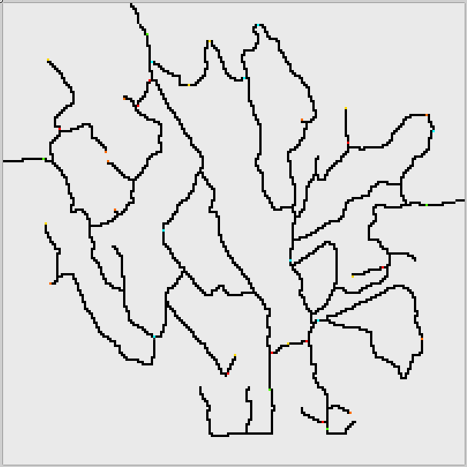 (The Map)

“Test Birds from Kasios” are the bird sounds Kasios claims as Pipits from across the Preserve. All of these recording were taken over the past couple of months. “Test Bird Locations” indicate where in the pixel map the bird sounds were recorded.

Example:

ID, X, Y

1,140,119

2,63,153